Ramon Baltazar  Instructor |  | Contact  RamonBaltazar  (714)683-1401  Ramon.Baltazar  @BUC.EDU  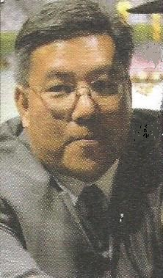

Experience
Academics-Teaching
Planned and implemented credit courses in Business and Management, Marketing, with the overall goal of assisting students towards a graduate /undergraduate/ associate degree /certificate in their field of study.
Los Angeles Harbor College • 2004 – Present
North Orange County Community District • 2006 - Present
California University of Mgmt. and Science • 2006 - Present
California State University Dominguez Hills • 2006 - Present
Bethesda University of California • 2008 – Present

Industry Operations - Management
Master planning and coordination of new, promotional, product assemblies prior to commercialization. Responsible for any and all logistics support for new products while servicing marketing, manufacturing, operations ,outside contractors and clients.
Merle Norman Cosmetics • 1989 -2004
Packaging Corporation of America• 1985– 1989
Allergan Pharmaceuticals • 1981- 1985
ITT Datanetics • 1979 – 1981

Education and Training
Graduate - University of Phoenix Masters in Business Administration
College - Ateneo De Manila University Bachelor of Arts in Communications
Certificate in Community College Teaching. Cal. State University Dominguez Hills
Certificate Program in Prod. And Materials Management, Cal. State Dominguez Hills
.

Academic Software
Blackboard, Canvas, Googleclass, Populi, Moodle.

Business Software
Microsoft Office, ERP MRPII , AmSoft & SAP Enterprise Software

Motto
“The world changes every second….
Knowledge grows exponentially everyday….
I can only share what I know…
And what I don’t know...I ask and learn”

